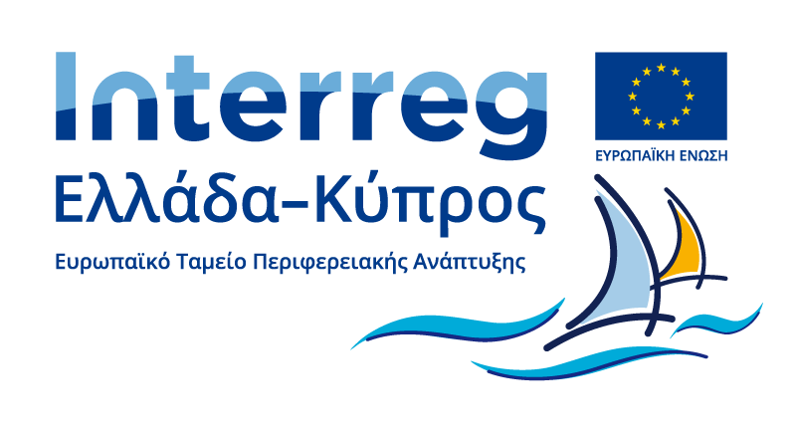

**Project: POLI-SYNERGIES**

**Cross-Border Synergies for Energy Saving in Police Buildings (POLI-SYNERGIES)**

**Project Duration:** March 2021-March 2023 (24 months).

**Budget:** For the Cyprus Police € 910,000 (Euro Nine Hundred Ten Thousand only).

The implementation of demonstration projects of Energy Saving (EXE) in the large number of energy-degraded buildings of the Greek and Cypriot Police and the development of "joint synergies" to achieve FDI by 50% in their buildings in 2050.

Overall Objective: Implementation of FDI demonstration projects in three (3) central public buildings of the Police with high attendance. The Act aims to achieve "synergies" in order to develop "common" interactive models - practices that will

raise awareness of Police officers / citizens and improve their environmental awareness in the area.

The building infrastructure is a significant consumer of energy and contributes to the total energy cost for the two Police forces both in Greece and in Cyprus. The integration of modern FDI technologies in buildings of the two Police, Greece and Cyprus will help reduce costs and carbon footprint and will be an example for the average Greek and Cypriot citizen who has to deal with the Police.

Concerns a partnership of the following Three (3) National Authorities / Beneficiaries:

1) Center for Renewable Sources and Energy Saving – CRES (GR)

2) Hellenic Police Headquarters - EL.AS.

3) Cyprus Police



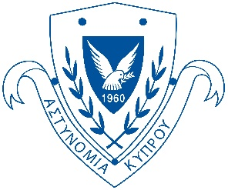

The Three (3) National Authorities / Beneficiaries:

- They plan a common framework of synergies for the implementation of "Appropriate Practices" for the strengthening of the FDI in the public building infrastructure of the National Authorities.

-Create collaborative actions that will create a "culture of further cooperation" in the two Authorities, as they will exchange know-how and will implement together the plan for the integration of smart and energy efficient technologies in their building infrastructure by 2050.

Mature Demonstration works in the following three (3) emblematic buildings of the Greek and Cypriot Police:

1) Chania Police Headquarters, EL.AS

2) Ayia Napa Police Station in Famagusta

3) Lakatameia Police Station, in Nicosia

The above buildings have been selected because:

1. a) They have a clear legal background, b) complete technical data are available, c) a clear mix of interventions has been selected.

2. They contribute in practice the "cooperative" achievement of the FDI target by 50% in the buildings of the Police of Greece and Cyprus by 2050.

3. They are located in central points, ensuring great visibility to citizens / visitors.

4. Innovative technologies are applied that will act as a model of good practice and for their employees, who will see an immediate improvement in the comfort they enjoy at work.

5. They contribute through the role of the Police as a "critical level" for the dissemination of the benefits of FDI to every citizen.











Specifically, at the Ayia Napa Police Station and Lakatameia Police Station, the following interventions will be performed:

. Replacement of interior lighting in buildings with corresponding Energy Saving LED technology

. Installation of External Thermal Insulation and Roof Thermal Insulation

. Replacement of all Frames with New Energy frames

. Creation of a Demonstrative Laboratory

. Energy Certificates and Operational Assessment of the Demonstrative Energy Saving Projects in the Buildings of the Cyprus Police in Famagusta & Nicosia based on the metering data.

The operation of the projects in the 3 buildings will be evaluated through the issuance of PEA and data from modern metering systems.

In this context, mutual publicity & information actions such as Publicity Material, Seminars, Conferences, Website, Video, Social Media have been planned.

